<http://supplymedium.com/wp-login.php>

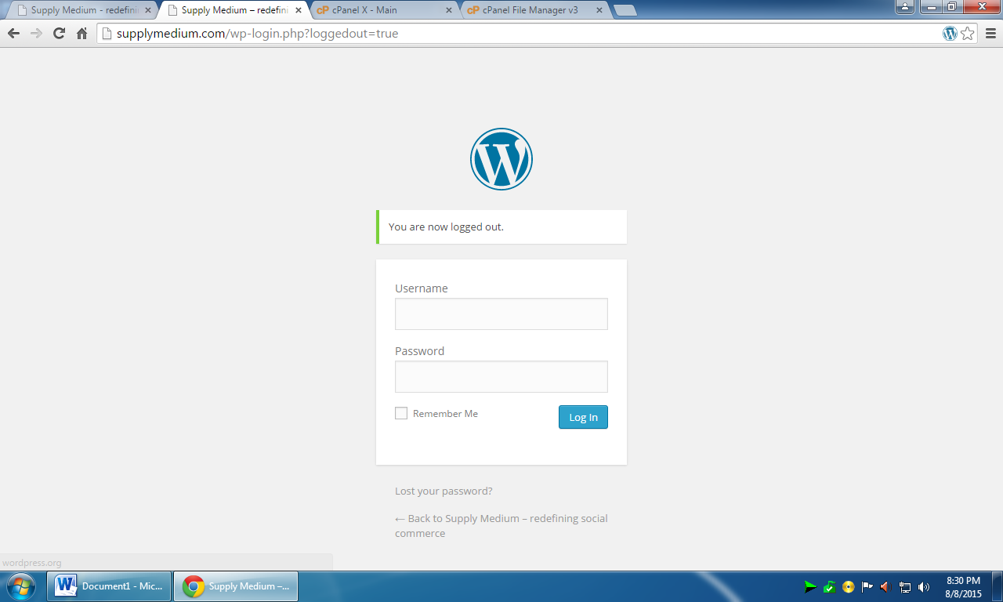

supplymedium

spl@#123

Dashboard

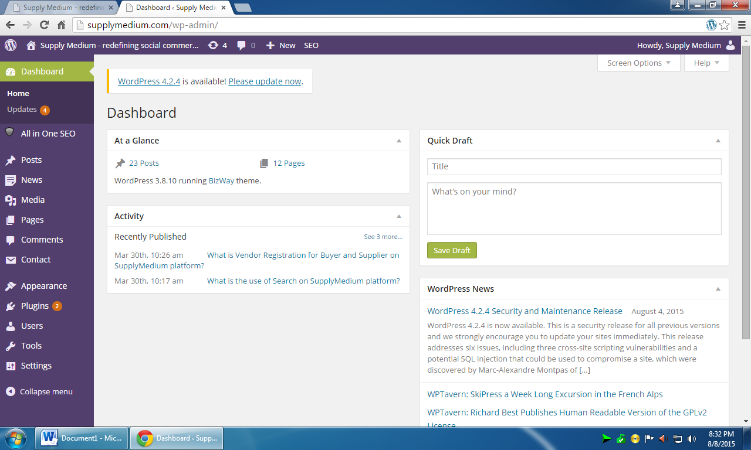

At left panel mouse hover on news >> Add News

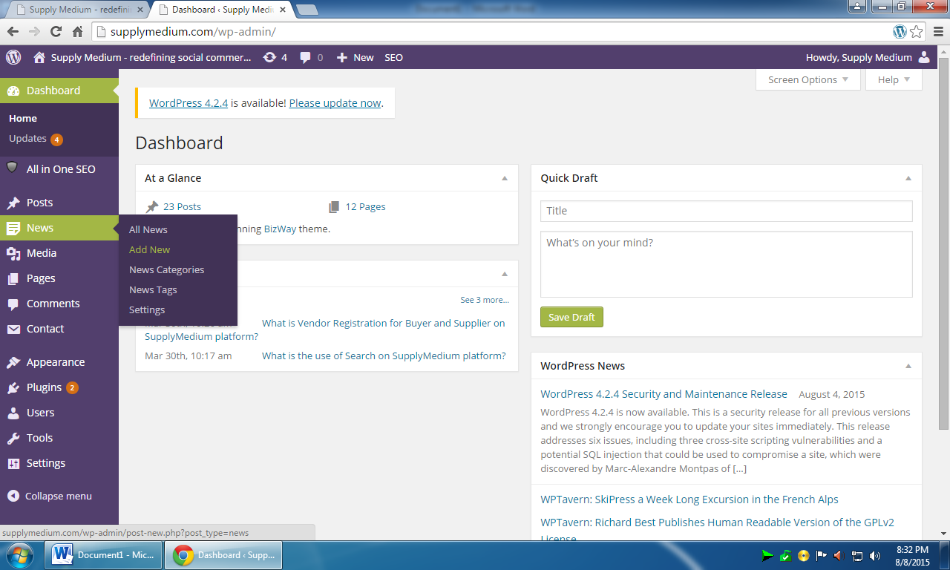

Add the title of news / blog

Add description

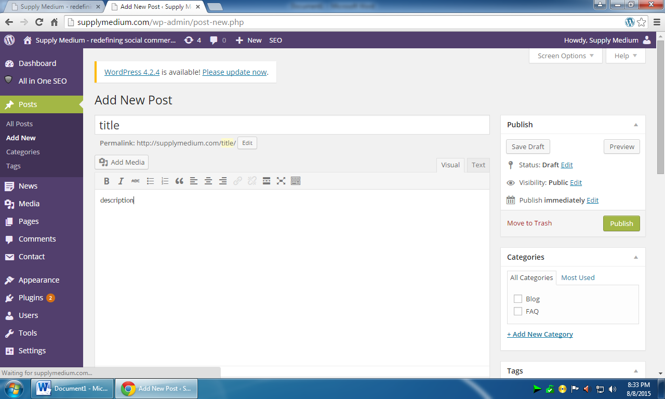

Add media will take you to upload and insert image into post

Select category Blog at right area >> complete and publish